**Week 2**

**Jupyter Notebook and JupyterLab**

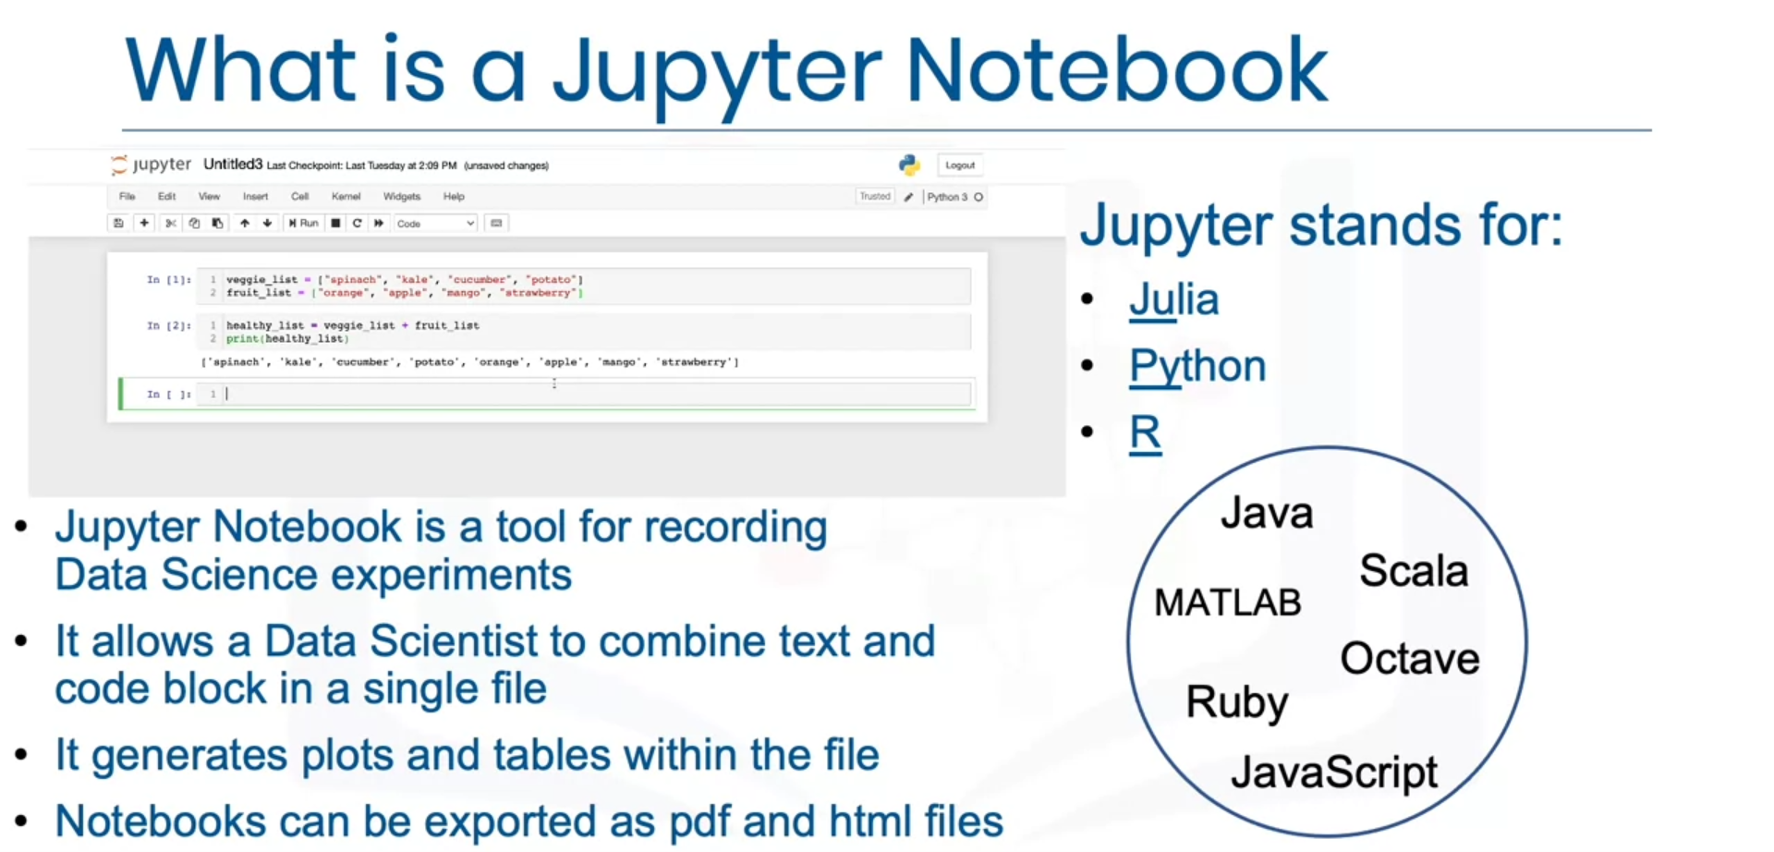

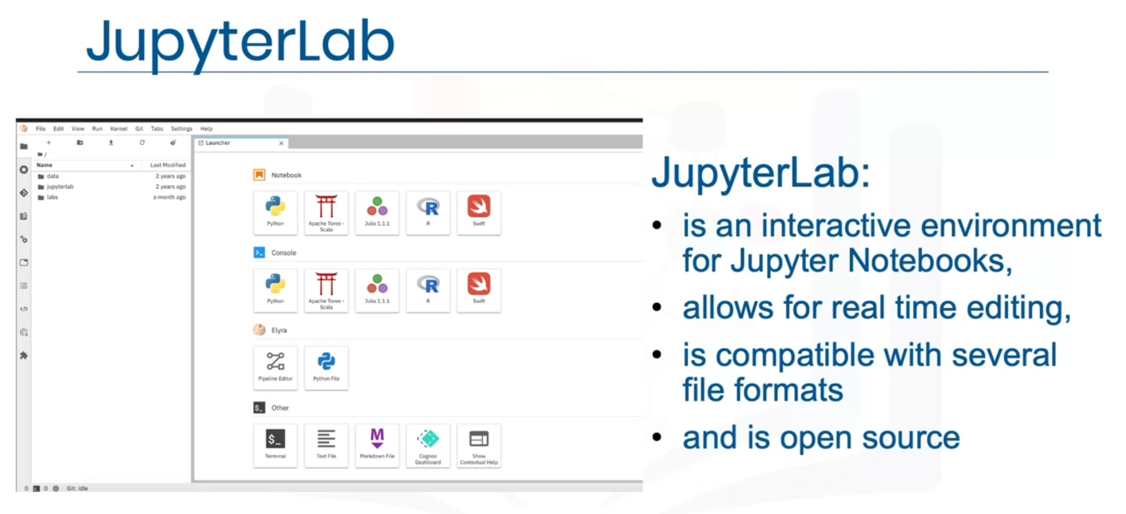



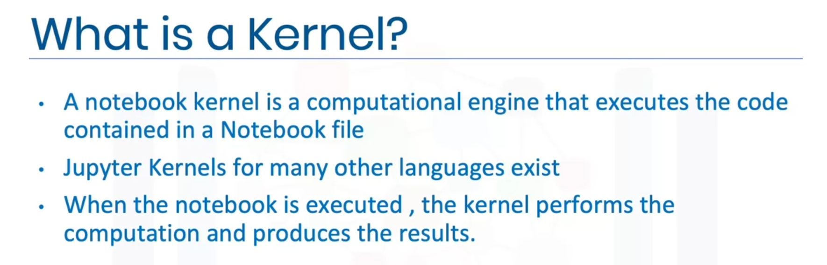

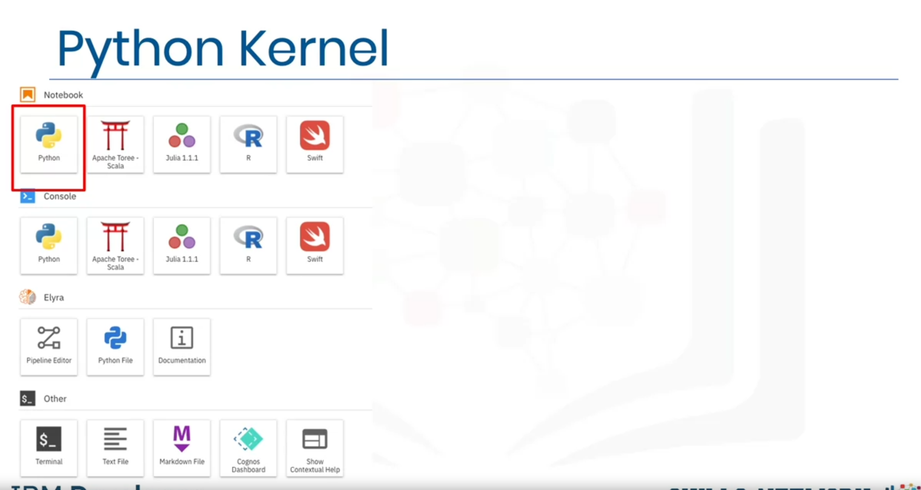

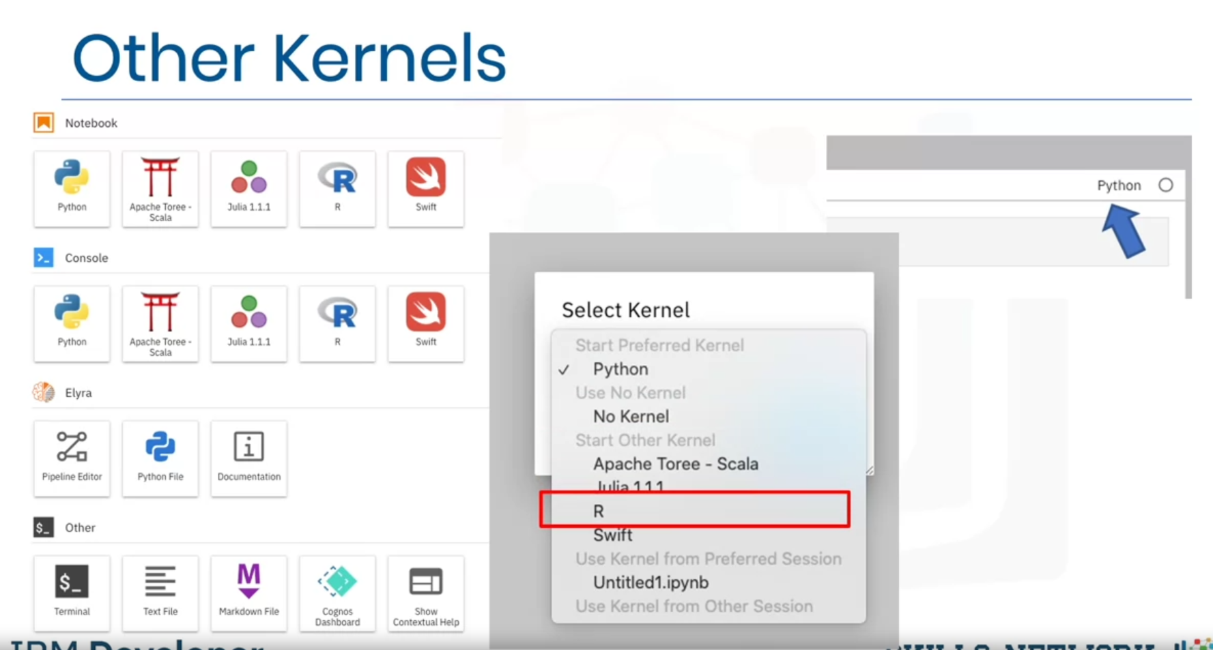

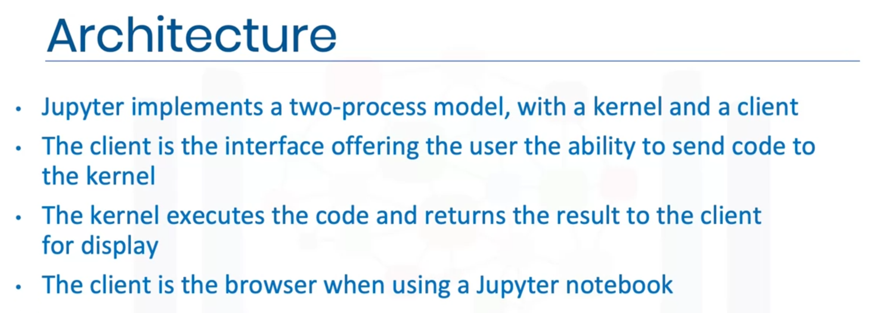

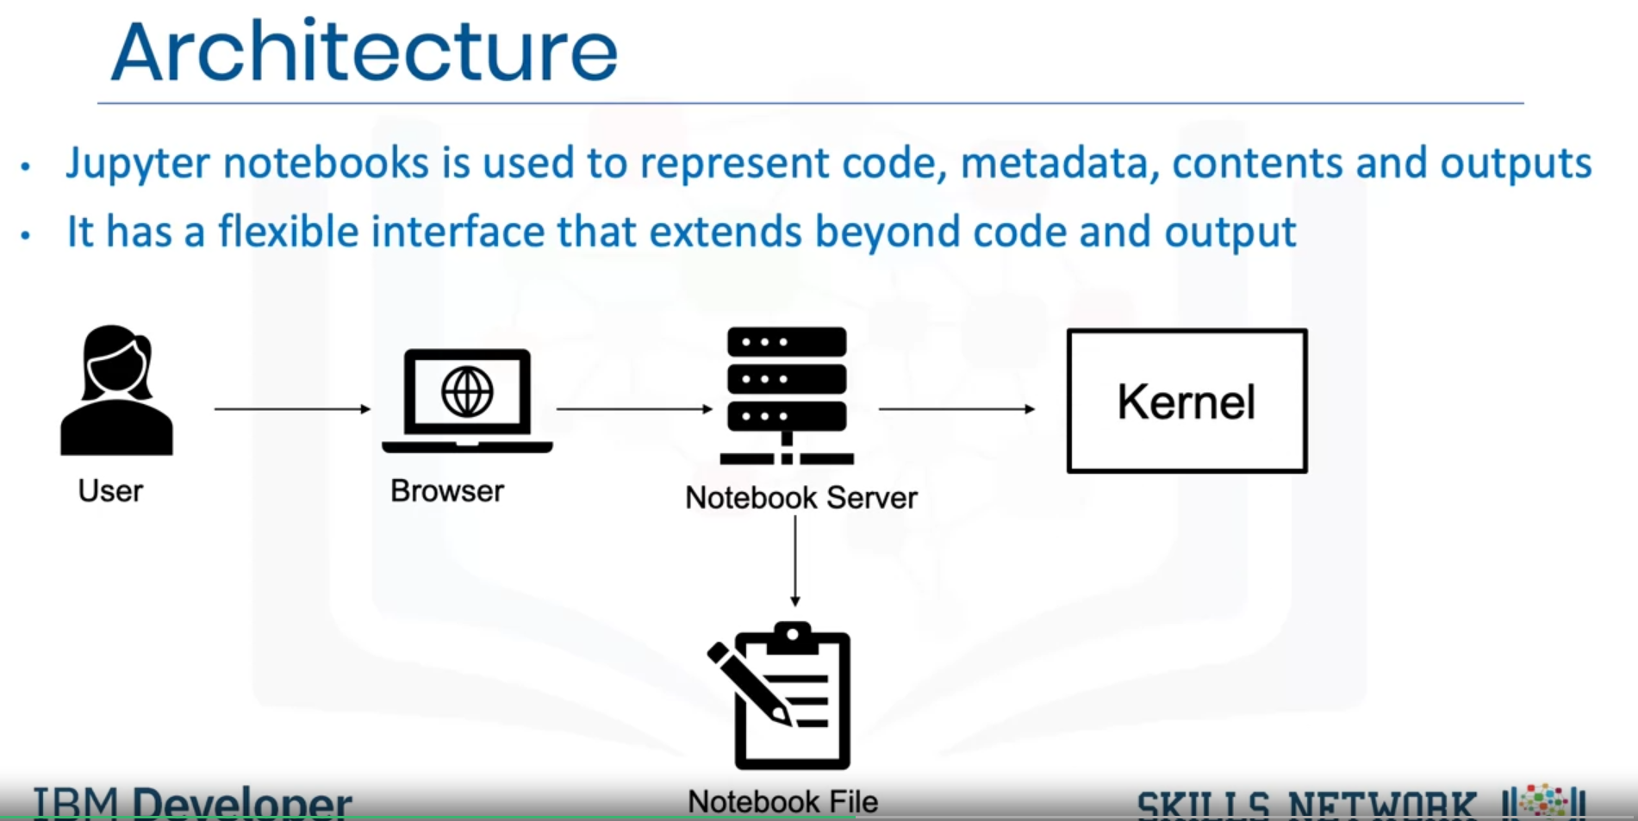

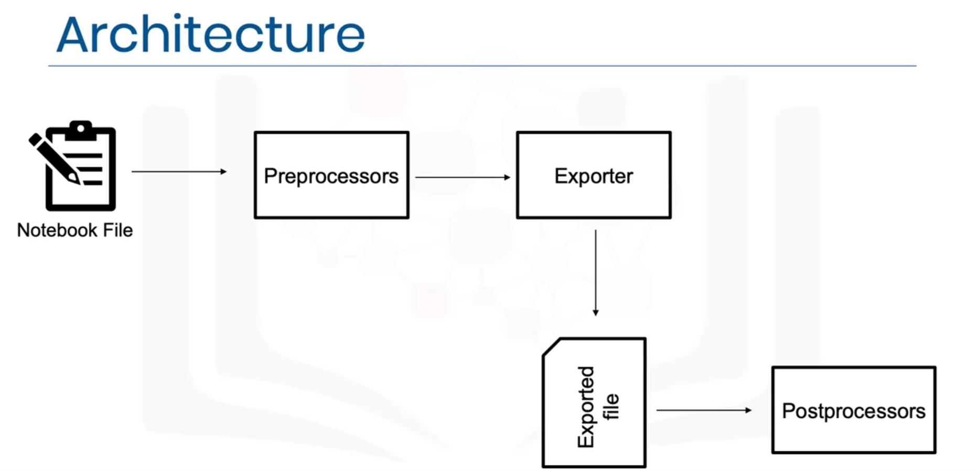

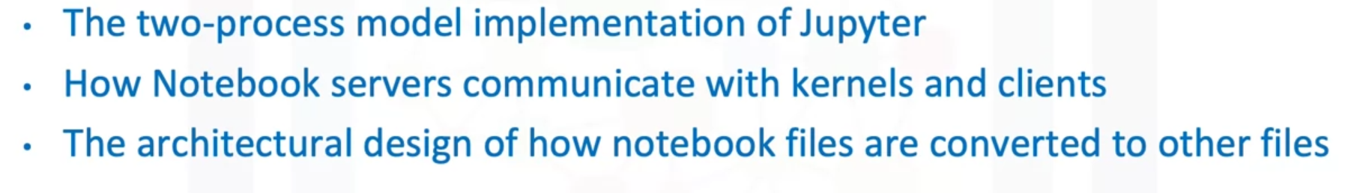

### Jupyter Notebooks on the Internet

There are thousands of interesting Jupyter Notebooks available on the internet for you to learn from. One of the best sources is: <https://github.com/jupyter/jupyter/wiki>

It is important to notice that you can download such notebooks to your local computer or import them to a cloud based notebook tool so that you can rerun, modify, and apply what's explained in the notebook.

Very often, Jupyter Notebooks are already shared in a rendered view. This means that you can look at them as if they were running locally on your machine. But sometimes, folks only share a link to the Jupyter file (which you can make out by the *.ipynb extension). In this case, you can pick the URL to that file and paste it to the NB-Viewer => <https://nbviewer.jupyter.org/>

The list of Jupyter Notebooks provides you with a huge collection of materials to explore. Therefore, it might be useful to give you some pointers to interesting notebooks. You have covered some examples with data in the labs. Let's highlight some useful data that further explores data science. In addition, as we have covered different tasks in data science, we will also provide a sample notebook for each task.

First, you start with exploratory data analysis, for which this notebook is highly recommended: <https://nbviewer.jupyter.org/github/Tanu-N-Prabhu/Python/blob/master/Exploratory_data_Analysis.ipynb>

For data integration/cleansing at a smaller scale, the python library_pandas_is often used. For this task, you can have a look at this notebook: <https://towardsdatascience.com/data-cleaning-with-python-using-pandas-library-c6f4a68ea8eb>

If you want to know more about clustering, have a look at this notebook: <https://nbviewer.jupyter.org/github/temporaer/tutorial_ml_gkbionics/blob/master/2%20-%20KMeans.ipynb>

And finally, if you want an in-depth notebook on the_iris_dataset, have a look at this: <https://www.kaggle.com/lalitharajesh/iris-dataset-exploratory-data-analysis>

**RStudio IDE**

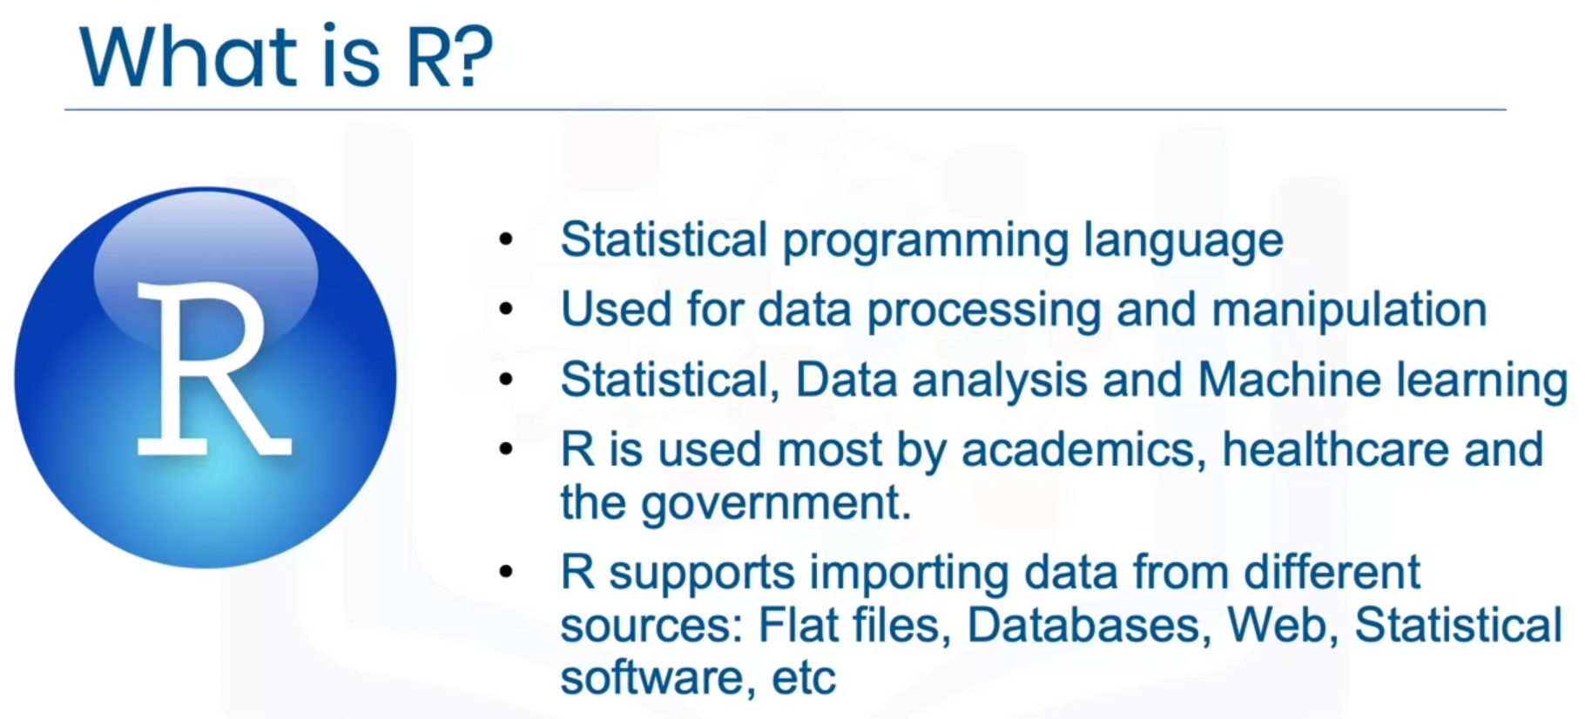

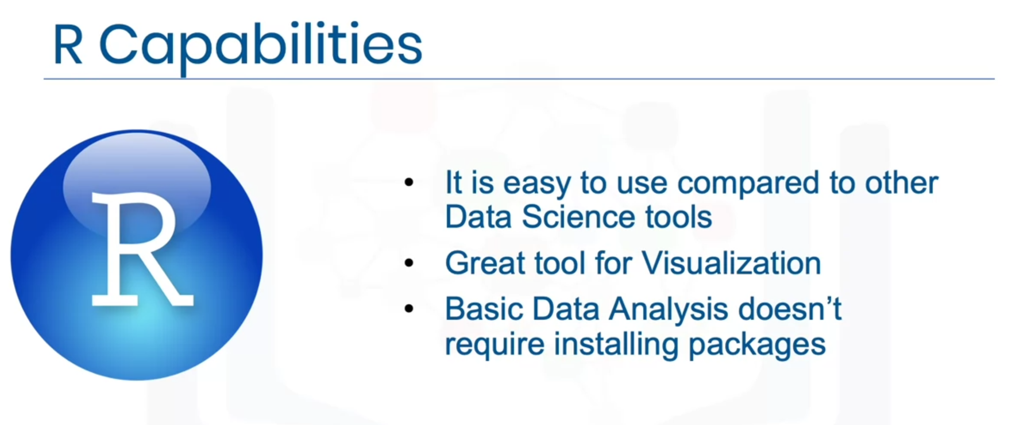

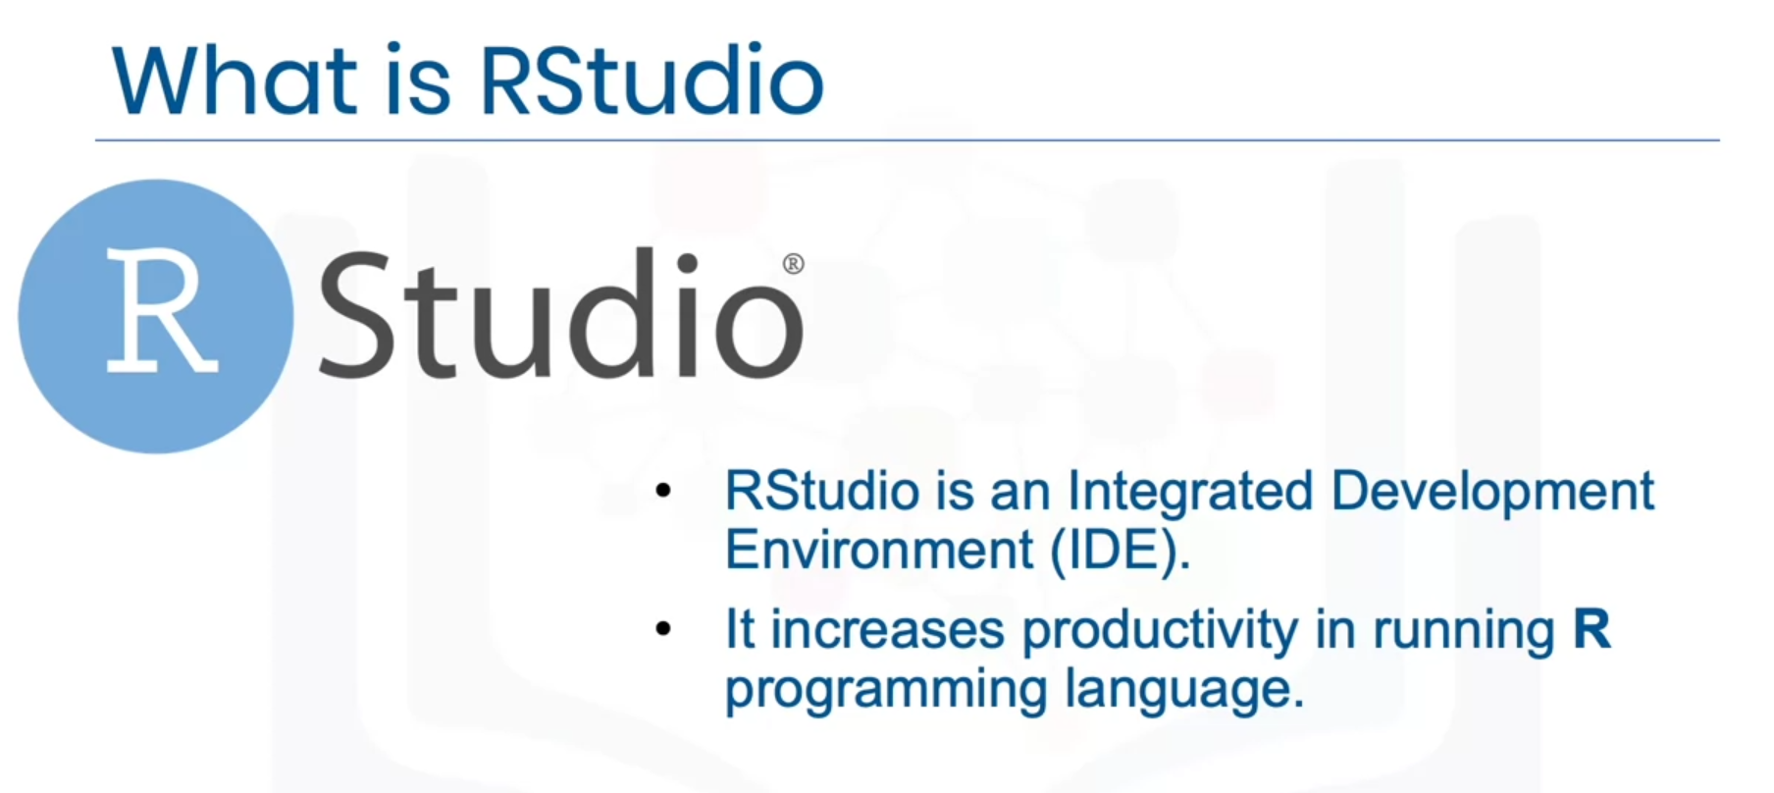

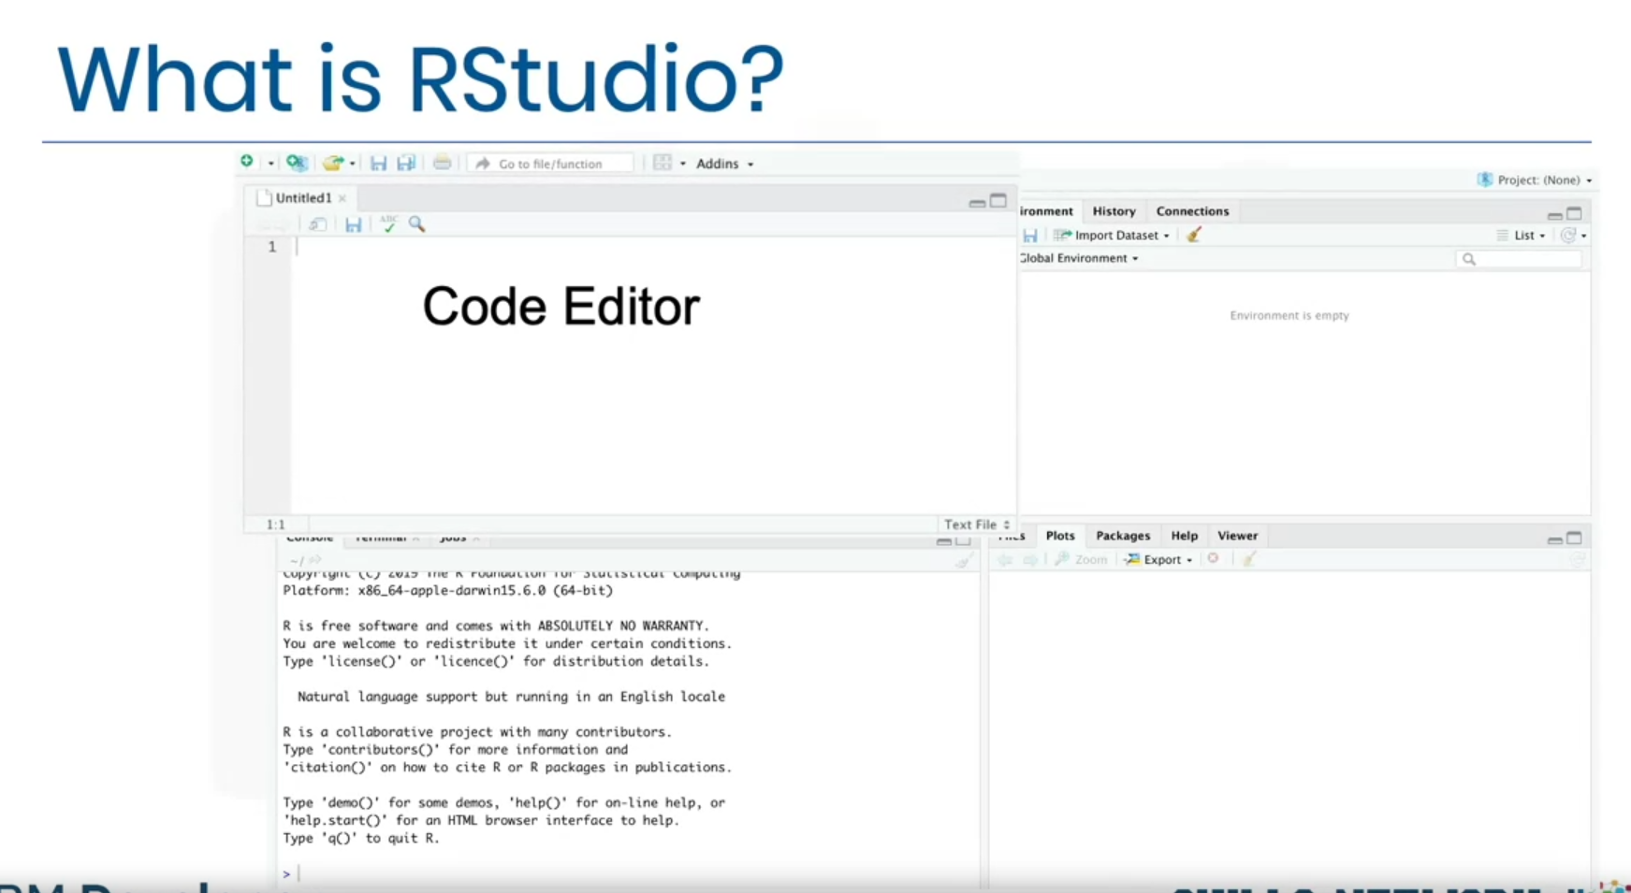

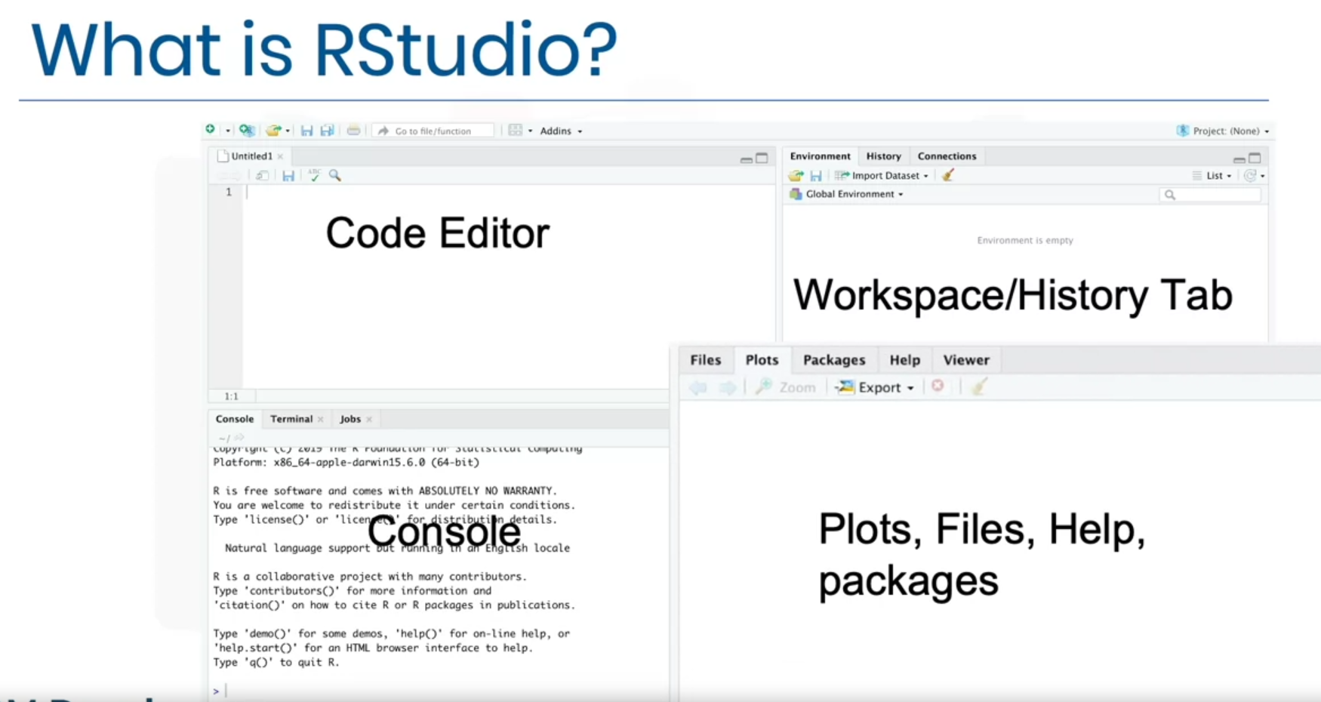

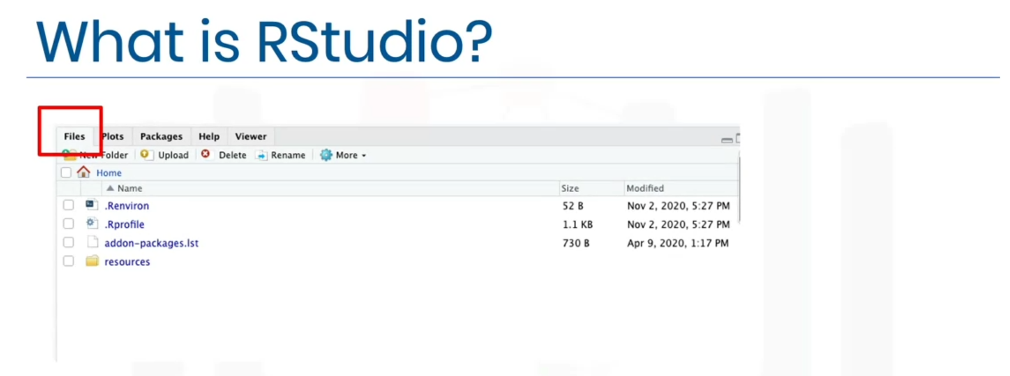

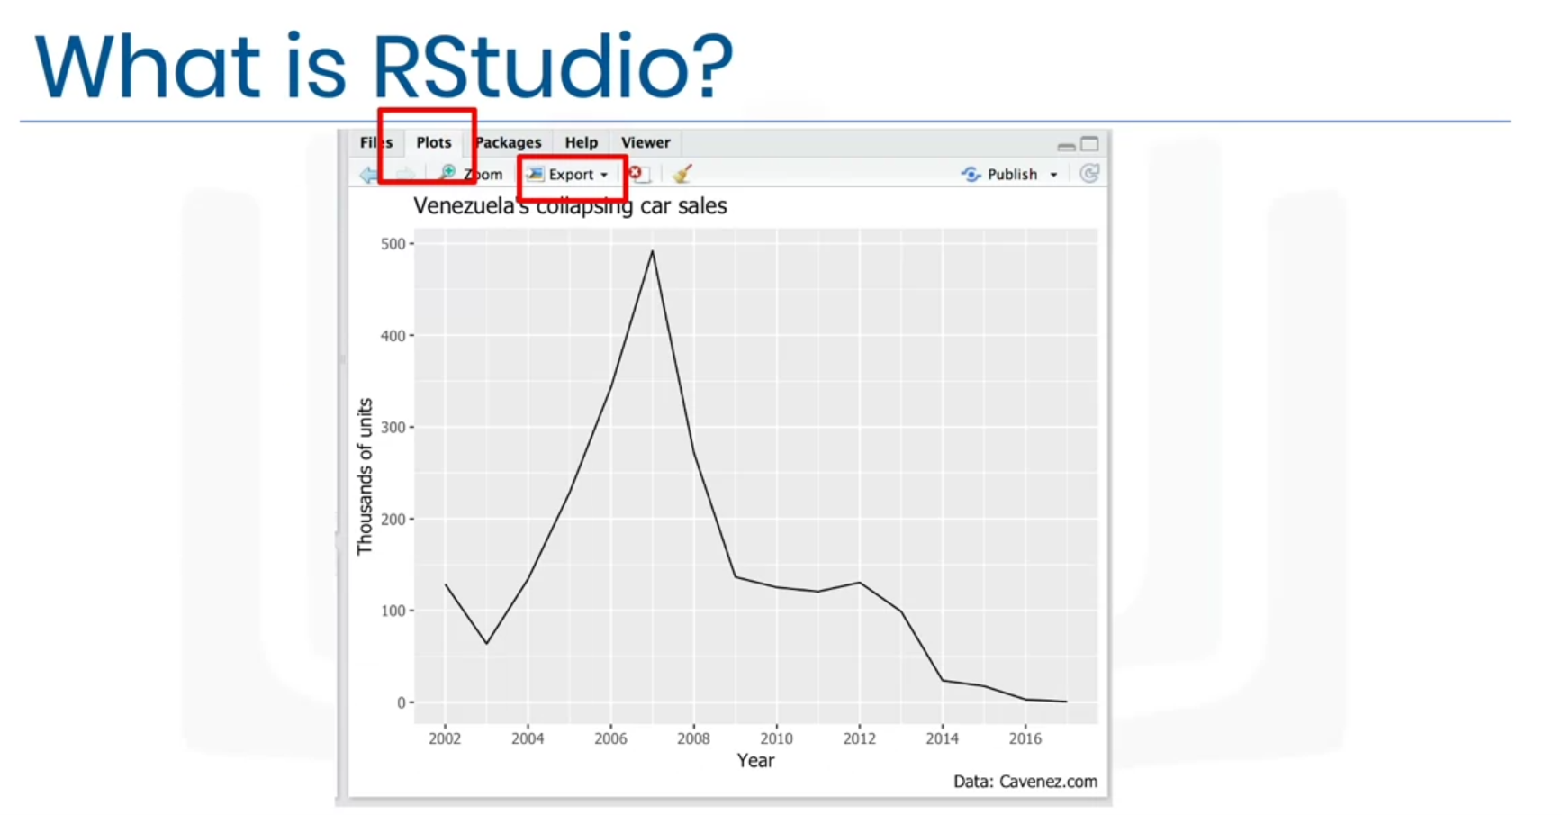

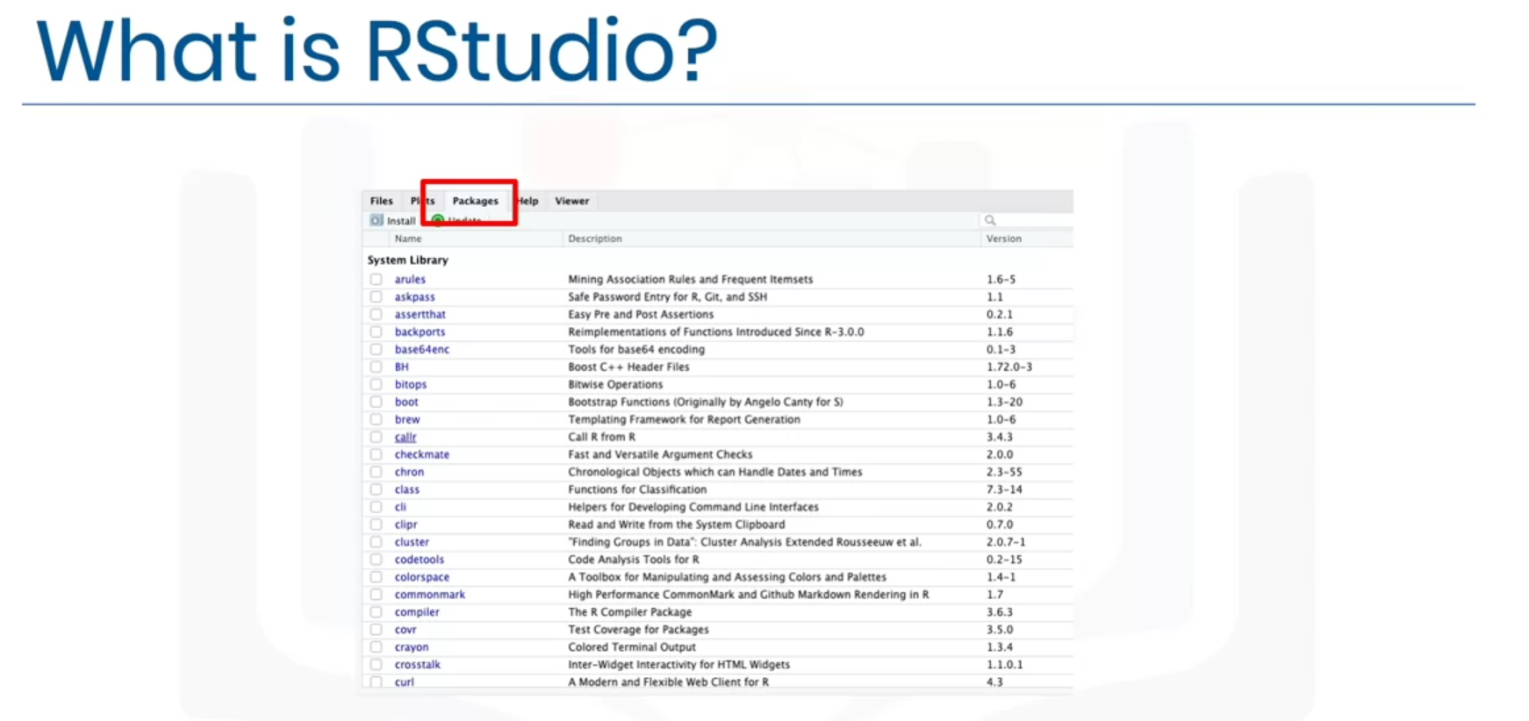

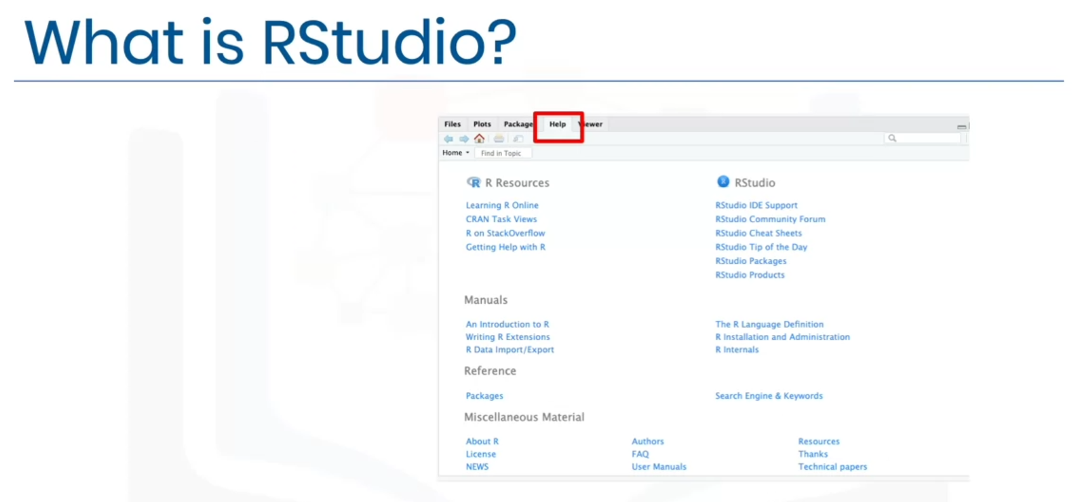

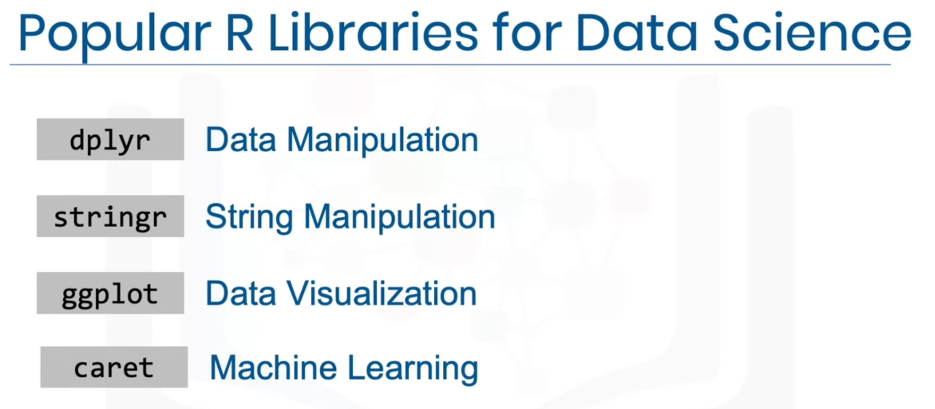

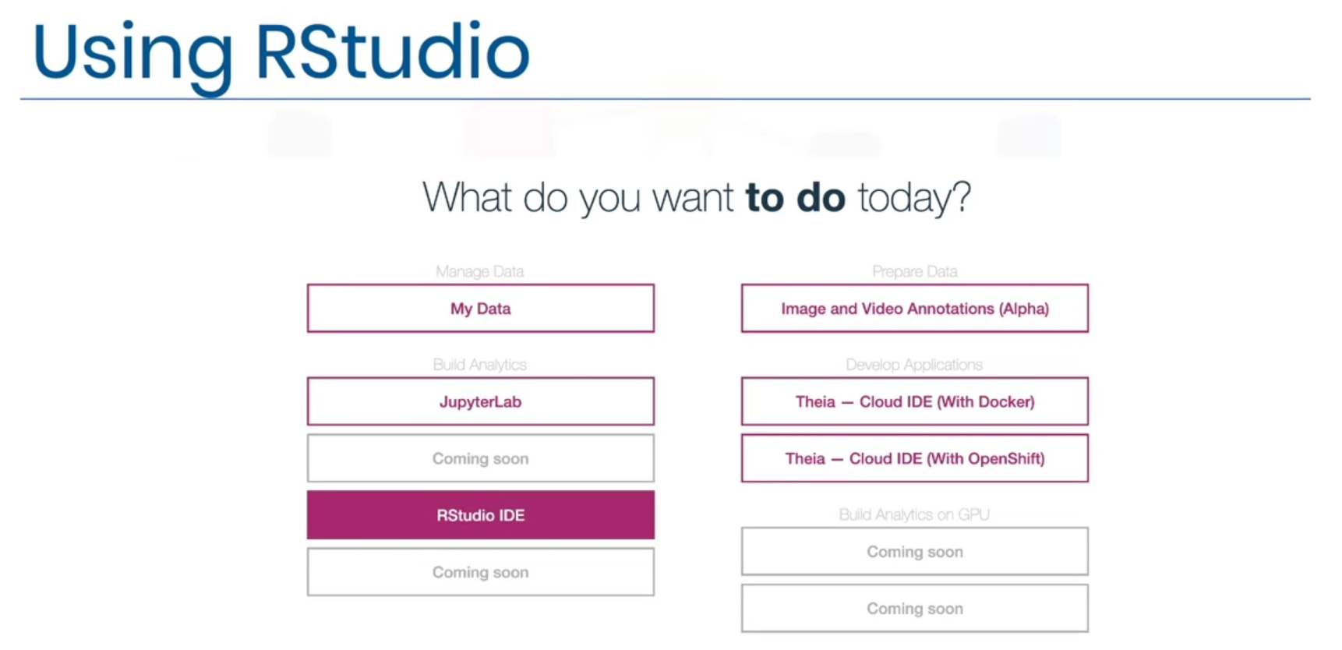

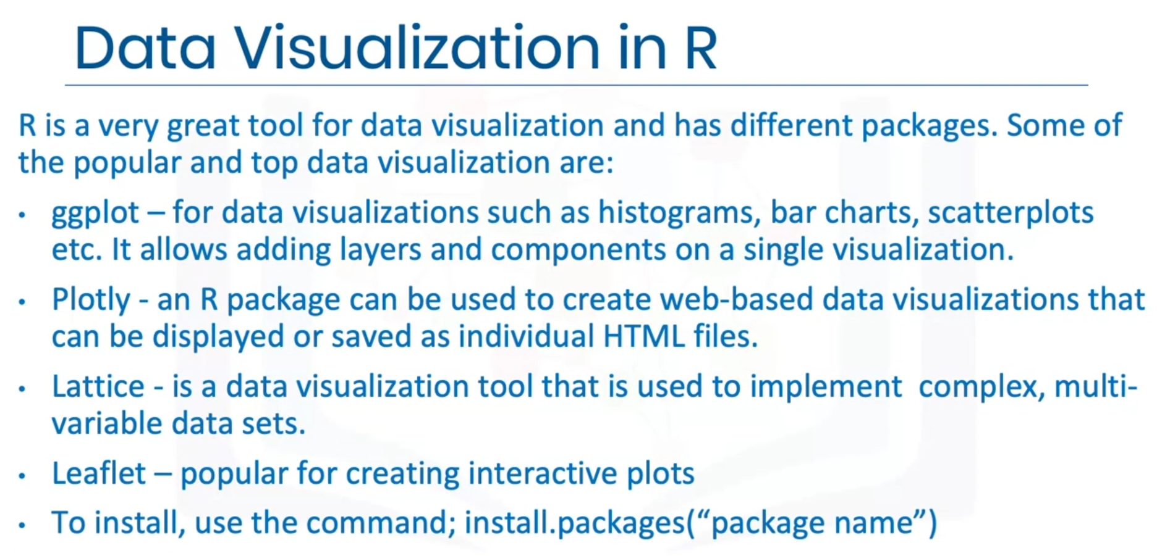

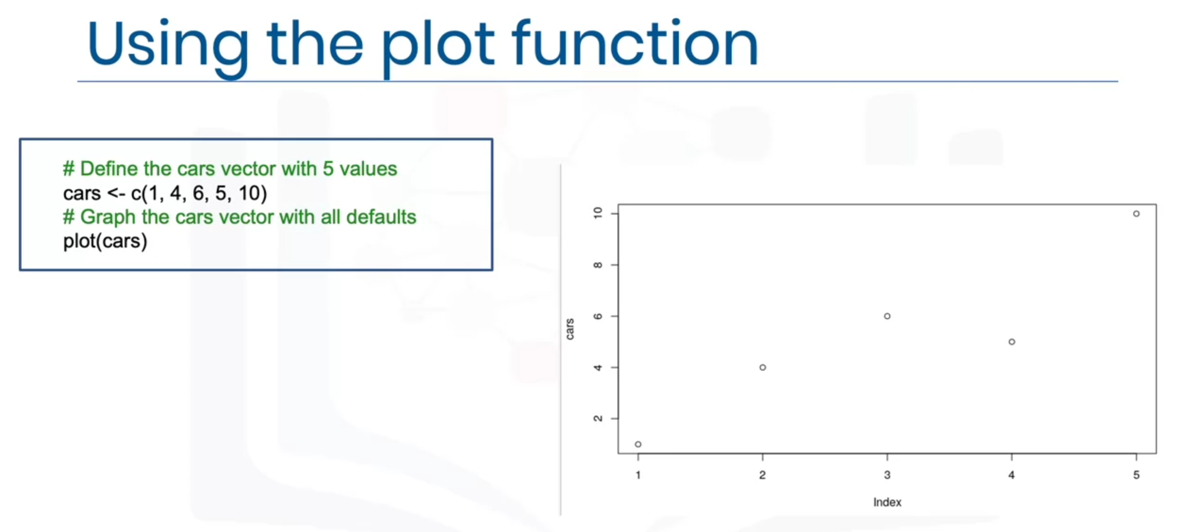

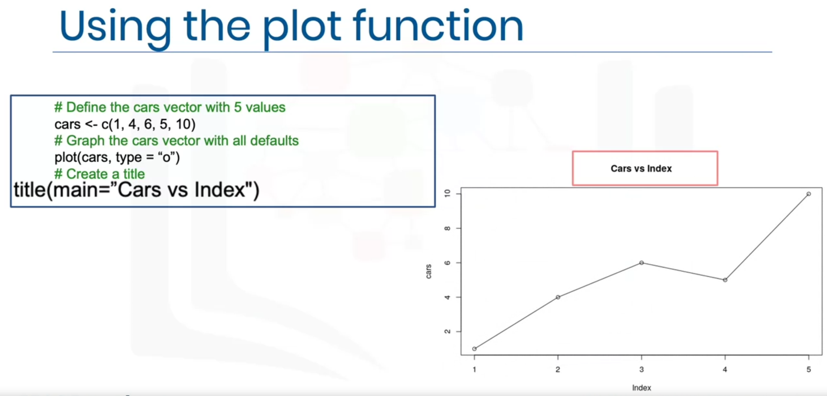

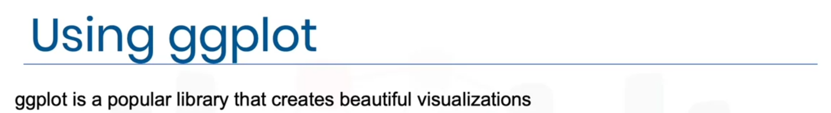

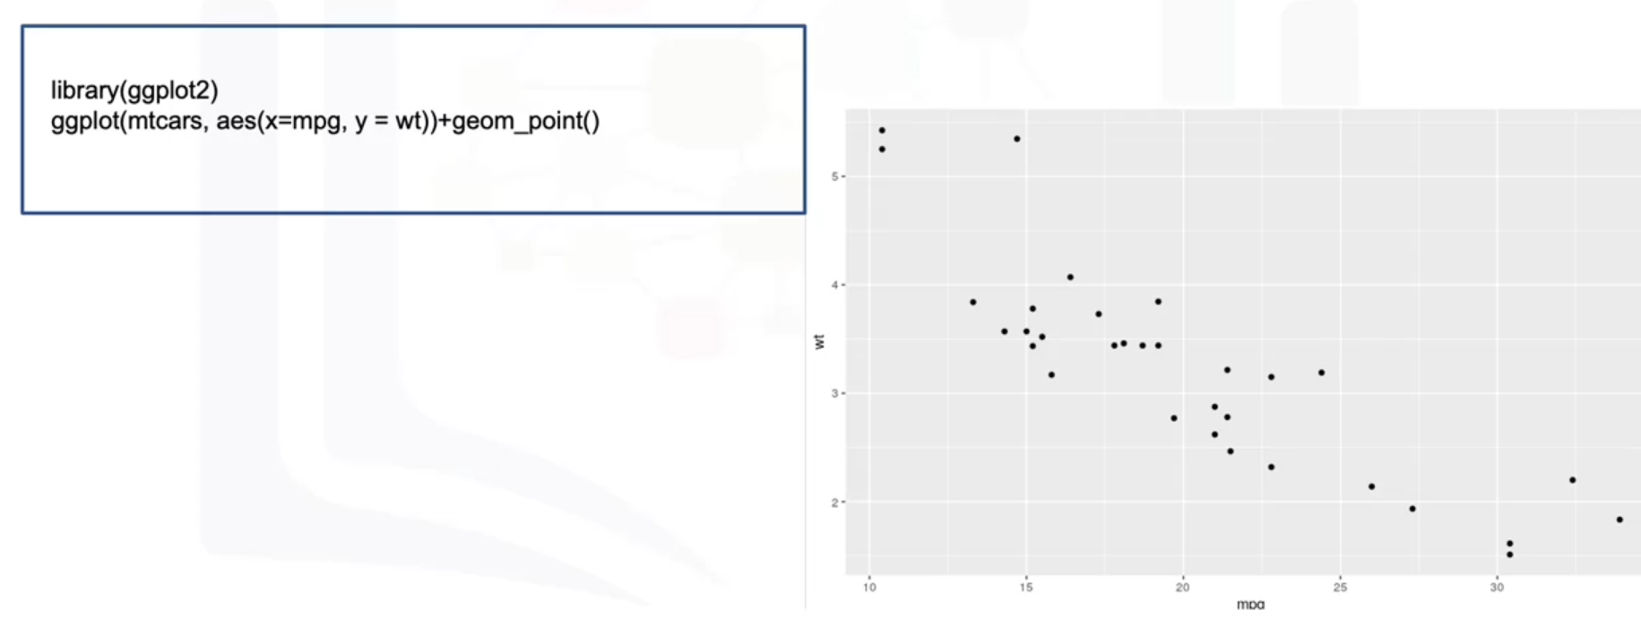

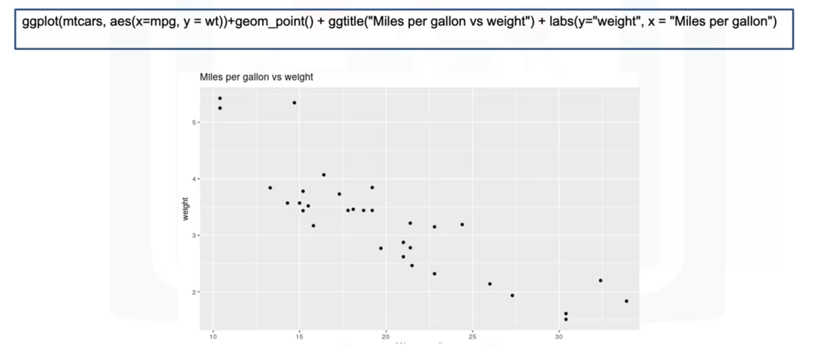

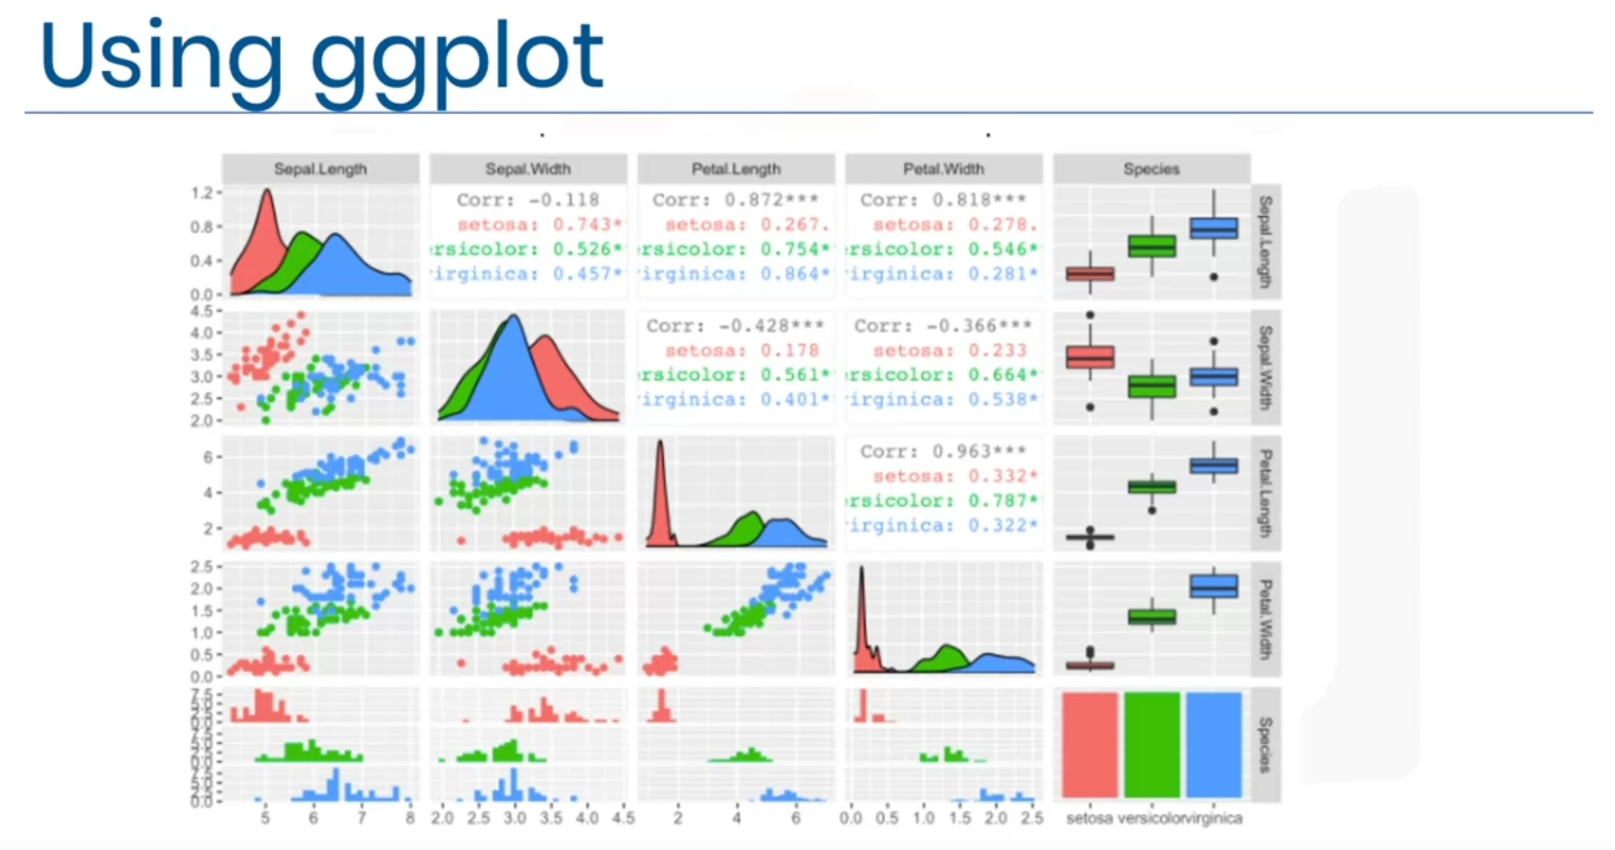

**Getting started with RStudio and Installing packages**

library(datasets)

data(iris)

View(iris)

unique(iris$Species)

Run this command in the console below:

install.packages("GGally", repos = "https://cran.r-project.org", type = "source")

Click Enter to install the package.

**Creating Data Visualizations using ggplot**

library(datasets)

data(mtcars)

head(mtcars, 5)

?mtcars

library(ggplot2)

ggplot(aes(x = disp, y = mpg, ), data = mtcars) + geom_point() + ggtitle("Displacement vs miles per gallon") + labs(x = "Displacement", y = "Miles per gallon")

mtcars$vs <- as.factor(mtcars$vs)

ggplot(aes(x = vs, y = mpg), data = mtcars) + geom_boxplot(alpha = 0.3) + theme(legend.position = "none")

ggplot(aes(x = wt), data = mtcars) + geom_histogram(binwidth = 0.5)

**Plotting within RStudio (Advanced)**

library(datasets)

data(iris)

View(iris)

library(GGally)

ggpairs(iris, mapping = ggplot2::aes(colour = Species))

**GitHub**

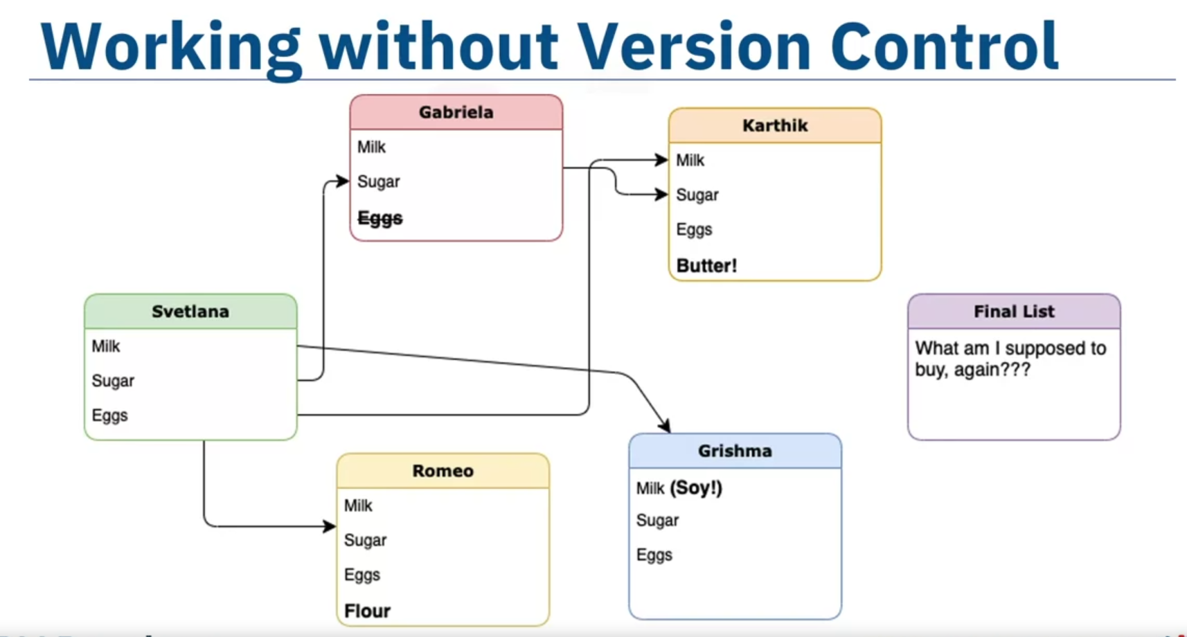 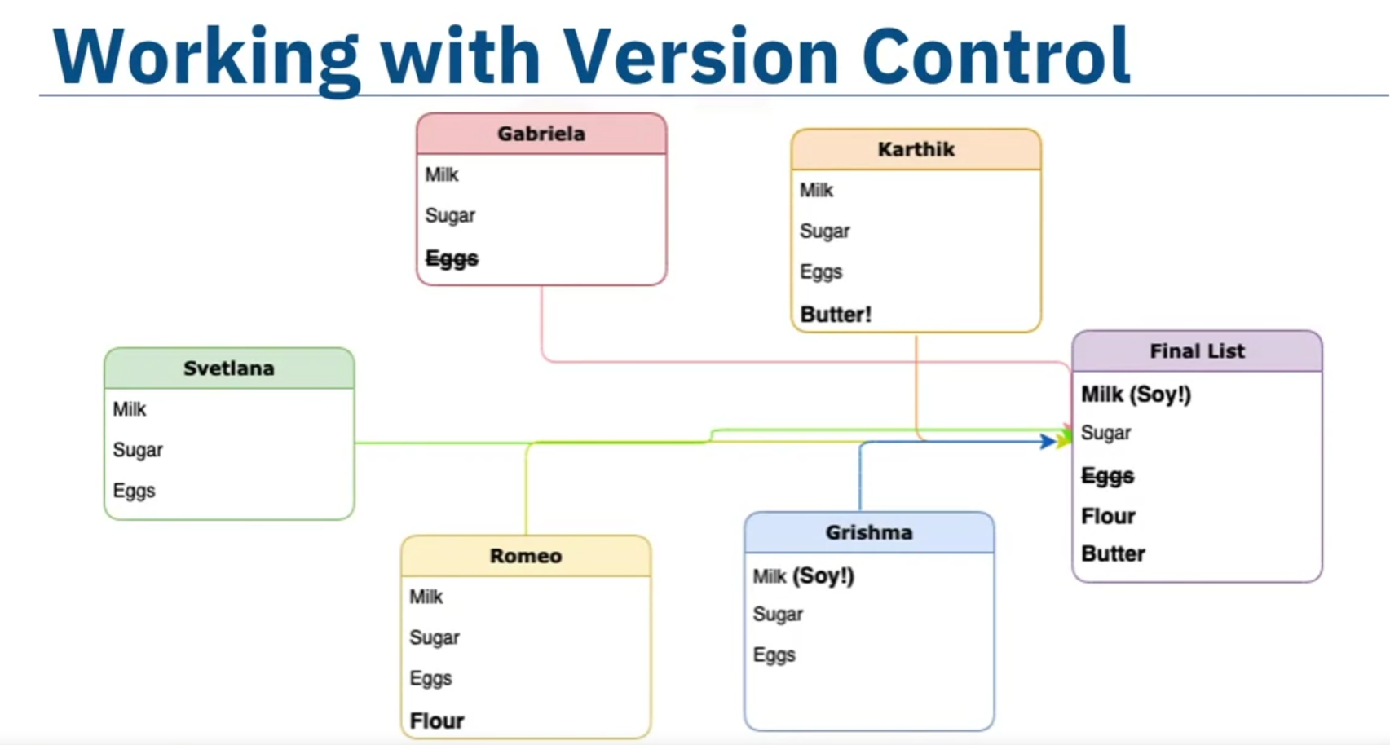

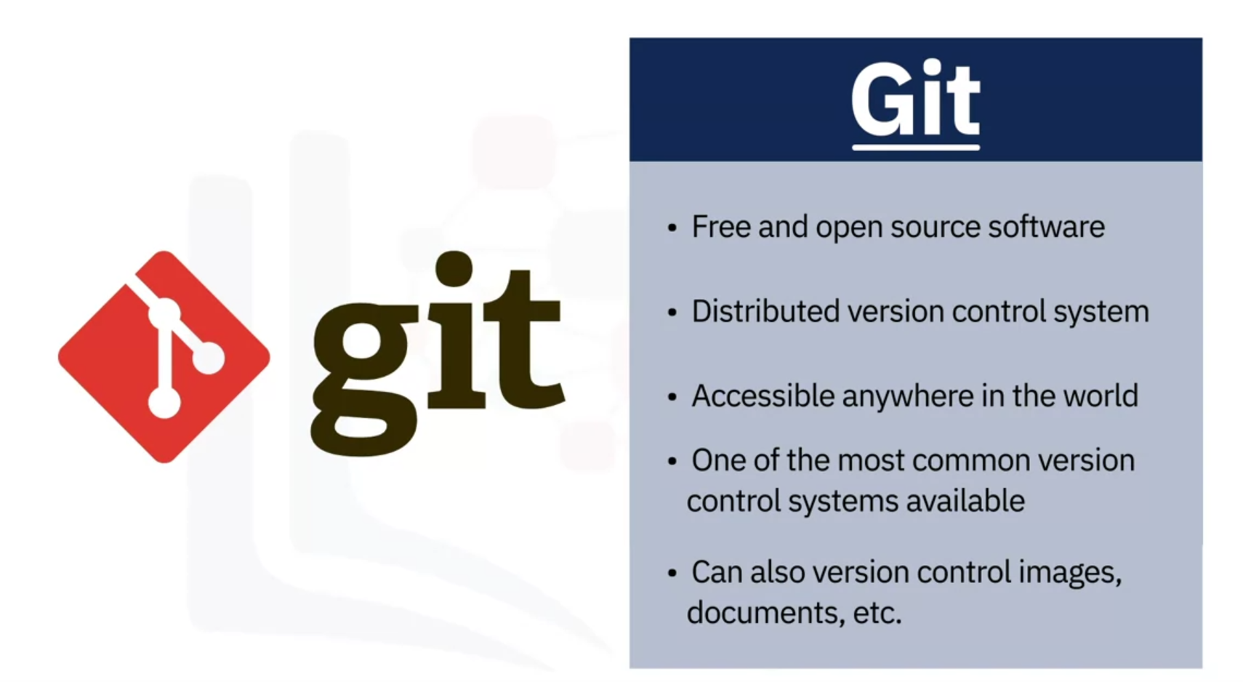



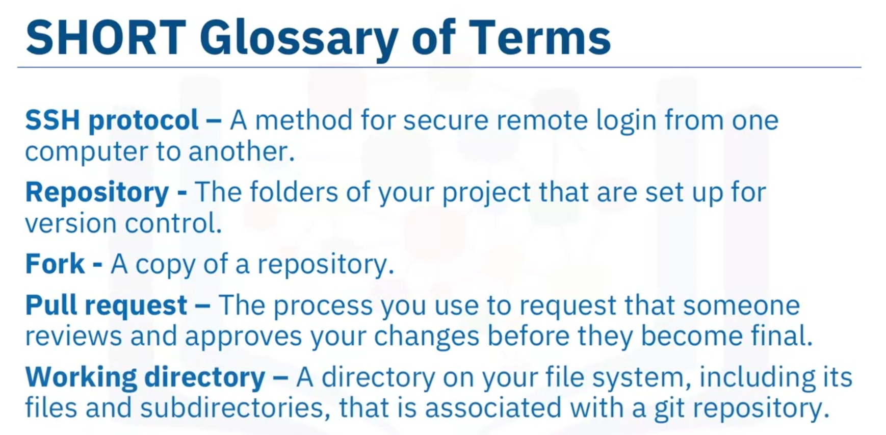

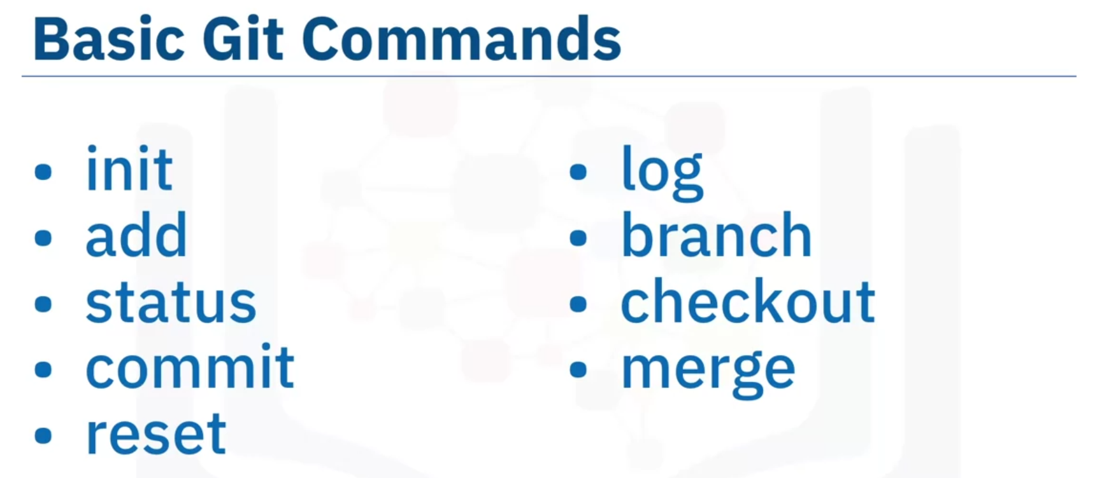

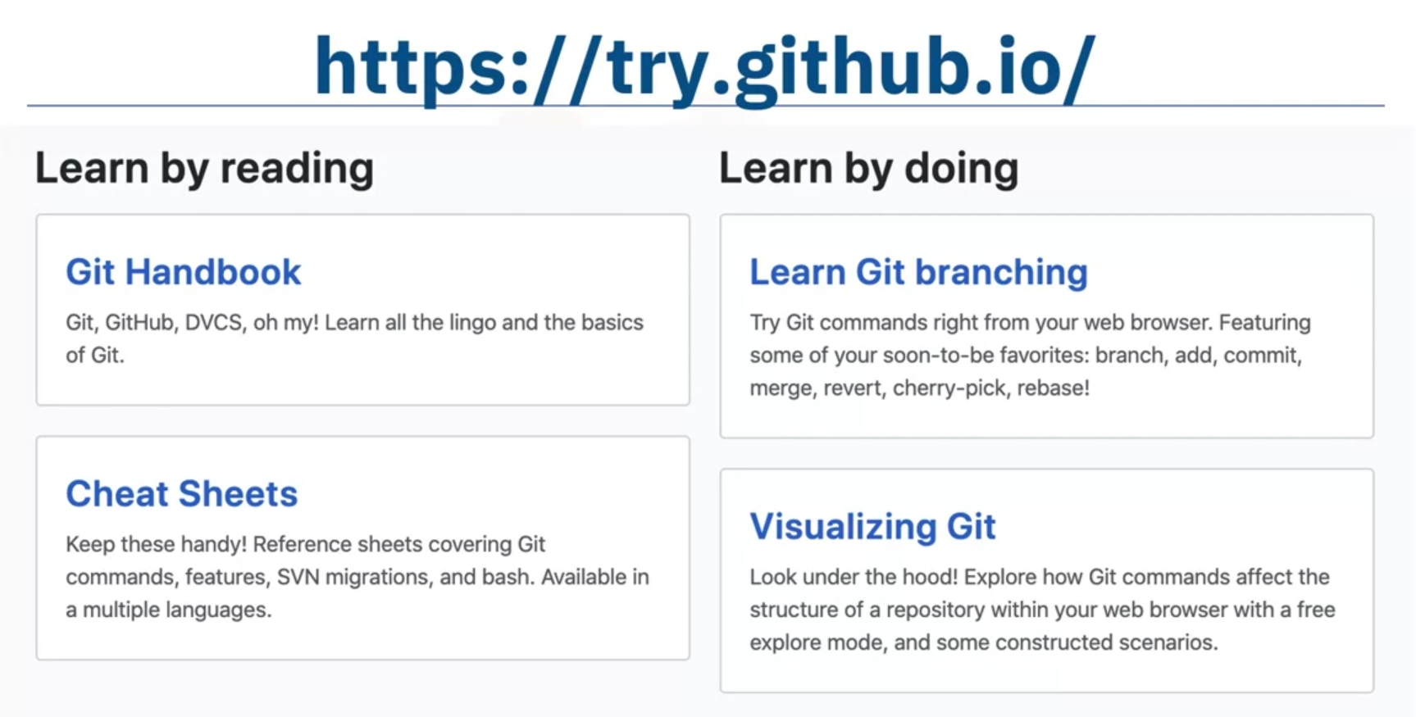

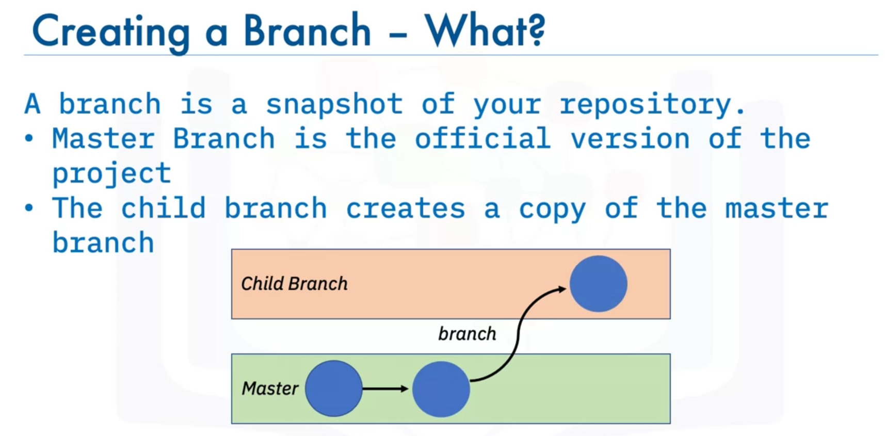

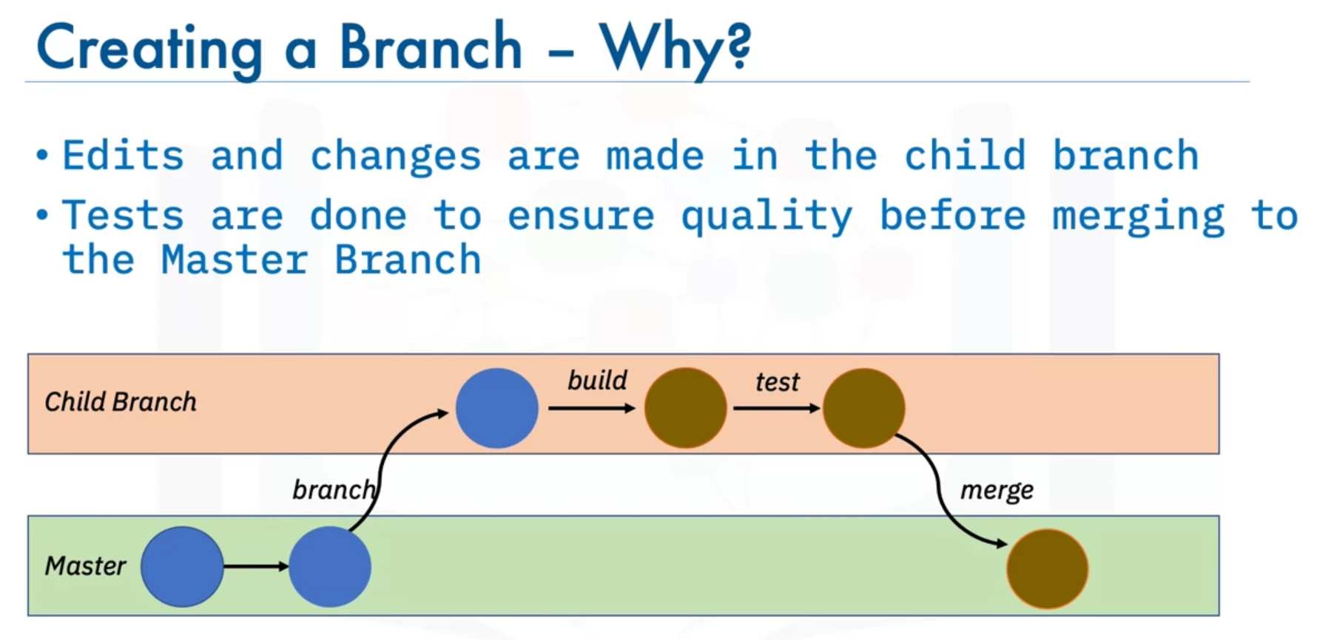

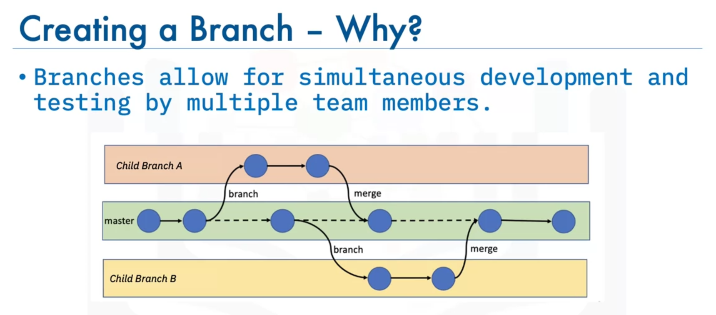

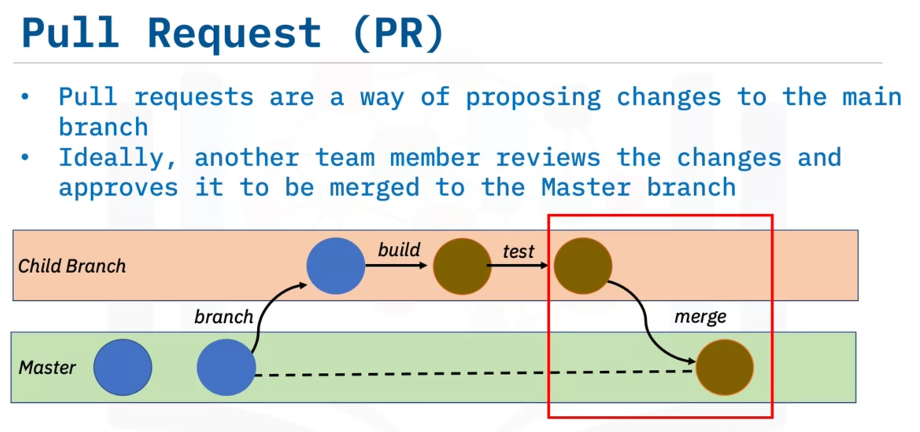

### Pre-requisites for working with GitHub on local machine:

**BASH Installation**

For Windows:

[GitBash Installation](https://cf-courses-data.s3.us.cloud-object-storage.appdomain.cloud/IBMDeveloperSkillsNetwork-DS0105EN-SkillsNetwork/labs/Module2/GitBash_Install.md.html?utm_medium=Exinfluencer&utm_source=Exinfluencer&utm_content=000026UJ&utm_term=10006555&utm_id=NA-SkillsNetwork-wwwcourseraorg-SkillsNetworkCoursesIBMDeveloperSkillsNetworkDS0105ENSkillsNetwork984-2022-01-01)

For Linux/Unix:

For Linux systems installing Git is easy. If you are using a Debian-based distribution like Ubuntu, you can use apt install:

$ sudo apt install git-all

For Fedora, RHEL or CentOS, you can use:

$ sudo dnf install git-all

For Mac:

Open the Terminal

Install homebrew if you don't already have it, then:

$ brew install git

**SSH Key generation**

[Generate SSH Key](https://cf-courses-data.s3.us.cloud-object-storage.appdomain.cloud/IBMDeveloperSkillsNetwork-DS0105EN-SkillsNetwork/labs/Module2/GitHub_SSHKey.md.html?utm_medium=Exinfluencer&utm_source=Exinfluencer&utm_content=000026UJ&utm_term=10006555&utm_id=NA-SkillsNetwork-wwwcourseraorg-SkillsNetworkCoursesIBMDeveloperSkillsNetworkDS0105ENSkillsNetwork984-2022-01-01)

Git is a system for version control of source code. Git is very useful for data science as well, since data science often involves a lot of source code to be written and managed.

The local repository is only accessible by myself. The staging is only accessible by myself. The remote repository is accessible by all contributors.

What is the best process for contributing a bugfix to a foreign repository? Fork the repository, update the fork and create a pull request.

1. Which are the two most used open source tools for data science?

* Notepad
* **RStudio**
* **Jupyter Notebooks / JupyterLab**
* Spyder
* VSCode

2. What tool do most R developers use?

* **RStudio**
* Jupyter Notebooks / JupyterLab

3. What tool do most Python developers use?

* RStudio
* **Jupyter Notebooks / JupyterLab**

4. True or false? Jupyter Notebooks / JupyterLab support development in R.

* **True**
* False

5. Which tool unifies documentation, source code and data visualizations into a single document?

* VSCode
* **Jupyter Notebooks / JupyterLab**
* Notepad

6. Which command is used to install packages in R?

* package(“package name”)
* **install.packages(“package name”)**
* install(“package name”)
* install.package(“package name”)

7. Which of the following functions does RStudio provide?

* Creating relationships between data tables.
* **Editing and execution of R code.**
* Storing data in tables.
* Documenting R code applications.

8. True or False: The Jupyter Notebook kernel must be installed on a local server.

* True
* **False**

9. Which of the following statements about Jupyter Notebook is correct?

* Jupyter Notebook is only available if installed locally on your computer.
* **Jupyter Notebook supports the Visualization of data in charts.**
* Jupyter Notebook provides storage of massive quantities of data in data lakes.
* Jupyter Notebook is a commercial product of IBM.

10. True or false? RStudio supports development in Python.

* **True**
* False

vanli@LAPTOP-OBAOFUBT MINGW64 ~

$ cd Downloads

vanli@LAPTOP-OBAOFUBT MINGW64 ~/Downloads

$ cd demo_test1

vanli@LAPTOP-OBAOFUBT MINGW64 ~/Downloads/demo_test1 (master)

$ README.md

bash: README.md: command not found

vanli@LAPTOP-OBAOFUBT MINGW64 ~/Downloads/demo_test1 (master)

$ dir README.md

README.md

vanli@LAPTOP-OBAOFUBT MINGW64 ~/Downloads/demo_test1 (master)

$ git pull

remote: Enumerating objects: 4, done.

remote: Counting objects: 100% (4/4), done.

remote: Compressing objects: 100% (3/3), done.

remote: Total 3 (delta 0), reused 0 (delta 0), pack-reused 0

Unpacking objects: 100% (3/3), 702 bytes | 78.00 KiB/s, done.

From github.com:svanli/demo_test1

4a4c949..2cd43cf master -> origin/master

Updating 4a4c949..2cd43cf

Fast-forward

newfile.txt | 1 +

1 file changed, 1 insertion(+)

create mode 100644 newfile.txt

vanli@LAPTOP-OBAOFUBT MINGW64 ~/Downloads/demo_test1 (master)

$ dir

README.md newfile.txt

vanli@LAPTOP-OBAOFUBT MINGW64 ~/Downloads/demo_test1 (master)

$ dir

README.md newfile.txt

vanli@LAPTOP-OBAOFUBT MINGW64 ~/Downloads/demo_test1 (master)

$ echo "#stuff on branch" >> stuffonbranch.txt

vanli@LAPTOP-OBAOFUBT MINGW64 ~/Downloads/demo_test1 (master)

$ git add stuffonbrach.txt

fatal: pathspec 'stuffonbrach.txt' did not match any files

vanli@LAPTOP-OBAOFUBT MINGW64 ~/Downloads/demo_test1 (master)

$ git add stuffonbranch.txt

warning: LF will be replaced by CRLF in stuffonbranch.txt.

The file will have its original line endings in your working directory

vanli@LAPTOP-OBAOFUBT MINGW64 ~/Downloads/demo_test1 (master)

$ git commit -m "add to the branch"

[master 399392c] add to the branch

1 file changed, 1 insertion(+)

create mode 100644 stuffonbranch.txt

vanli@LAPTOP-OBAOFUBT MINGW64 ~/Downloads/demo_test1 (master)

$ git push

Enumerating objects: 4, done.

Counting objects: 100% (4/4), done.

Delta compression using up to 8 threads

Compressing objects: 100% (2/2), done.

Writing objects: 100% (3/3), 331 bytes | 331.00 KiB/s, done.

Total 3 (delta 0), reused 0 (delta 0), pack-reused 0

To github.com:svanli/demo_test1.git

2cd43cf..399392c master -> master

vanli@LAPTOP-OBAOFUBT MINGW64 ~/Downloads/demo_test1 (master)

$ git push

Everything up-to-date

vanli@LAPTOP-OBAOFUBT MINGW64 ~/Downloads/demo_test1 (master)

$ dir

README.md newfile.txt stuffonbranch.txt

vanli@LAPTOP-OBAOFUBT MINGW64 ~/Downloads/demo_test1 (master)

$ echo "Text in the file" >> testfile1.txt

vanli@LAPTOP-OBAOFUBT MINGW64 ~/Downloads/demo_test1 (master)

$ git add testfile1.txt

warning: LF will be replaced by CRLF in testfile1.txt.

The file will have its original line endings in your working directory

vanli@LAPTOP-OBAOFUBT MINGW64 ~/Downloads/demo_test1 (master)

$ git commit -m "add to the branch"

[master 2b72993] add to the branch

1 file changed, 1 insertion(+)

create mode 100644 testfile1.txt

vanli@LAPTOP-OBAOFUBT MINGW64 ~/Downloads/demo_test1 (master)

$ git push

Enumerating objects: 4, done.

Counting objects: 100% (4/4), done.

Delta compression using up to 8 threads

Compressing objects: 100% (2/2), done.

Writing objects: 100% (3/3), 291 bytes | 291.00 KiB/s, done.

Total 3 (delta 1), reused 0 (delta 0), pack-reused 0

remote: Resolving deltas: 100% (1/1), completed with 1 local object.

To github.com:svanli/demo_test1.git

399392c..2b72993 master -> master

vanli@LAPTOP-OBAOFUBT MINGW64 ~/Downloads/demo_test1 (master)

$ git push --set-upstream origin mybranch

error: src refspec mybranch does not match any

error: failed to push some refs to 'github.com:svanli/demo_test1.git'

vanli@LAPTOP-OBAOFUBT MINGW64 ~/Downloads/demo_test1 (master)

$ git push

Everything up-to-date

vanli@LAPTOP-OBAOFUBT MINGW64 ~/Downloads/demo_test1 (master)

$ git branch mybranch

vanli@LAPTOP-OBAOFUBT MINGW64 ~/Downloads/demo_test1 (master)

$ git checkout mybranch

Switched to branch 'mybranch'

vanli@LAPTOP-OBAOFUBT MINGW64 ~/Downloads/demo_test1 (mybranch)

$ echo "Text example in a branch file" >> testfileinbranch.txt

vanli@LAPTOP-OBAOFUBT MINGW64 ~/Downloads/demo_test1 (mybranch)

$ git add testfileinbranch.txt

warning: LF will be replaced by CRLF in testfileinbranch.txt.

The file will have its original line endings in your working directory

vanli@LAPTOP-OBAOFUBT MINGW64 ~/Downloads/demo_test1 (mybranch)

$ git commit -m "add to the branch"

[mybranch ab8dc24] add to the branch

1 file changed, 1 insertion(+)

create mode 100644 testfileinbranch.txt

vanli@LAPTOP-OBAOFUBT MINGW64 ~/Downloads/demo_test1 (mybranch)

$ git push

fatal: The current branch mybranch has no upstream branch.

To push the current branch and set the remote as upstream, use

git push --set-upstream origin mybranch

vanli@LAPTOP-OBAOFUBT MINGW64 ~/Downloads/demo_test1 (mybranch)

$ git push --set upstream origin mybranch

error: src refspec origin does not match any

error: failed to push some refs to 'upstream'

vanli@LAPTOP-OBAOFUBT MINGW64 ~/Downloads/demo_test1 (mybranch)

$ git push --set-upstream origin mybranch

Enumerating objects: 4, done.

Counting objects: 100% (4/4), done.

Delta compression using up to 8 threads

Compressing objects: 100% (2/2), done.

Writing objects: 100% (3/3), 312 bytes | 312.00 KiB/s, done.

Total 3 (delta 1), reused 0 (delta 0), pack-reused 0

remote: Resolving deltas: 100% (1/1), completed with 1 local object.

remote:

remote: Create a pull request for 'mybranch' on GitHub by visiting:

remote: https://github.com/svanli/demo_test1/pull/new/mybranch

remote:

To github.com:svanli/demo_test1.git

* [new branch] mybranch -> mybranch

Branch 'mybranch' set up to track remote branch 'mybranch' from 'origin'.

vanli@LAPTOP-OBAOFUBT MINGW64 ~/Downloads/demo_test1 (mybranch)

$ git push

Everything up-to-date

vanli@LAPTOP-OBAOFUBT MINGW64 ~/Downloads/demo_test1 (mybranch)

$ git checkout master

Switched to branch 'master'

Your branch is up to date with 'origin/master'.

vanli@LAPTOP-OBAOFUBT MINGW64 ~/Downloads/demo_test1 (master)

$ git merge mybranch

Updating 2b72993..ab8dc24

Fast-forward

testfileinbranch.txt | 1 +

1 file changed, 1 insertion(+)

create mode 100644 testfileinbranch.txt

vanli@LAPTOP-OBAOFUBT MINGW64 ~/Downloads/demo_test1 (master)

$ git push

Total 0 (delta 0), reused 0 (delta 0), pack-reused 0

To github.com:svanli/demo_test1.git

2b72993..ab8dc24 master -> master

vanli@LAPTOP-OBAOFUBT MINGW64 ~/Downloads/demo_test1 (master)

$ git clone git@github.com:svanli/TensorFlow.git

Cloning into 'TensorFlow'...

remote: Enumerating objects: 131, done.

remote: Total 131 (delta 0), reused 0 (delta 0), pack-reused 131

Receiving objects: 100% (131/131), 206.34 KiB | 155.00 KiB/s, done.

Resolving deltas: 100% (56/56), done.

vanli@LAPTOP-OBAOFUBT MINGW64 ~/Downloads/demo_test1 (master)

$ cd TensorFlow

vanli@LAPTOP-OBAOFUBT MINGW64 ~/Downloads/demo_test1/TensorFlow (master)

$ git add .

vanli@LAPTOP-OBAOFUBT MINGW64 ~/Downloads/demo_test1/TensorFlow (master)

$ git commit -m "Made changes in README.md file"

[master 4800e78] Made changes in README.md file

1 file changed, 2 insertions(+)

vanli@LAPTOP-OBAOFUBT MINGW64 ~/Downloads/demo_test1/TensorFlow (master)

$ git push

Enumerating objects: 5, done.

Counting objects: 100% (5/5), done.

Delta compression using up to 8 threads

Compressing objects: 100% (3/3), done.

Writing objects: 100% (3/3), 313 bytes | 313.00 KiB/s, done.

Total 3 (delta 2), reused 0 (delta 0), pack-reused 0

remote: Resolving deltas: 100% (2/2), completed with 2 local objects.

To github.com:svanli/TensorFlow.git

72b3599..4800e78 master -> master